

CSE 2004: DBMS

REVIEW 3

**EMPLOYEE DATABASE**

**AND PAYROLL**

**MANAGEMENT SYSTEM**

**SLOT**: **L29+L30**

**FACULTY: Dr. PRADEEP KKUMAR ROY**

**19BCE0770 – UPPAALA SRI HARSHITHA**

**19BCE0428 – CHAMA JAHNAVI**

**INTRODUCTION:**

The proposed project “Employee Database and Payroll Management System” has been developed to overcome the problems faced in the practicing of manual system. This software is built to eliminate and, in some cases, reduce the hardships faced by the existing system. Moreover, this system is designed for particular need of the company to carry out its operations in a smooth and effective manner. This application is reduced as much as possible to avoid errors while entering data. It also provides error message while entering invalid data. It is user-friendly as no formal knowledge is required to use the system. Our project is to give a simple and attractive application to organizations which maintains data of employee related which will simplify the work as well as reduce the efforts while doing it manually or we can say by doing it with old methods. Human resource challenges are faced by every organization which has to be overcome by the organization. Every organization has different employee and payroll management needs. Therefore, I have design exclusive Employee and payroll Management System that are adapted to the organization’s Managerial Requirements.

**ABSTRACT:**

Payroll system is the heart of any Human Resource System of an organization. The solution has to take care of the calculation of salary as per rules of the company, income tax calculation and various deductions to be done from the salary including statutory deductions like Income tax and provident fund deductions. It has to generate pay-slip, cheque summary and MIS reports. It is understood that we are tired of managing thousands of odd papers, pay slips, payroll reports, and salary details and so on. Imagine that we have a payroll processing system which will generate our pay slips and payroll reports within seconds. We can help others automated your payroll system by developing a customized payroll application that suits your specific requirements.

1. **ER Diagram of the Task:**

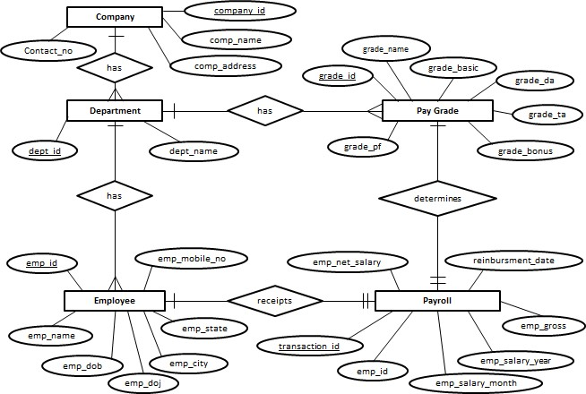

**2.Reduce ERD to Conceptual Schema.**

**Company**

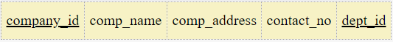

**department**

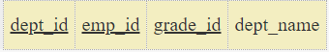

**employee**



**payroll**



**paygrade**



**3.Implement the Schema (Oracle Table)**

**Create table admin**

CREATE TABLE `admin` (

`id` int(50) NOT NULL,

`username` varchar(100) NOT NULL,

`password` varchar(100) NOT NULL

) ENGINE=InnoDB DEFAULT CHARSET=latin1;

--

-- Dumping data for table `admin`

--

INSERT INTO `admin` (`id`, `username`, `password`) VALUES

(1, '1604071', '12345'),

(2, '1604070', 'montu');

**Create department table**

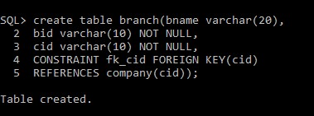

**Alter department**

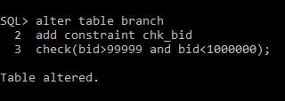

**Create table Employee**

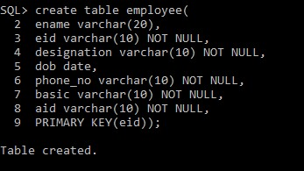

**Alter Employee**

ALTER TABLE `employee`

ADD PRIMARY KEY (`Employee_id`),

ADD KEY `Depart_id` (`Depart_id`),

ADD KEY `managesDepart_id` (`managesDepart_id`);

ALTER TABLE `employee`

ADD CONSTRAINT `employee_ibfk_1` FOREIGN KEY (`Depart_id`) REFERENCES

`department` (`Depart_id`),

ADD CONSTRAINT `employee_ibfk_2` FOREIGN KEY (`managesDepart_id`) REFERENCES `department` (`Depart_id`);

**Create Payment table**

CREATE TABLE `payment` (

`pay_no` int(11) NOT NULL,

`emp_id` varchar(100) NOT NULL,

`name` varchar(100) NOT NULL,

`accno` int(20) NOT NULL,

`year` int(11) NOT NULL,

`month` varchar(50) NOT NULL,

`absence` int(11) NOT NULL,

`loan_cut` float NOT NULL,

`pfund_cut` float NOT NULL,

`overtime` float NOT NULL,

`season_bonus` float NOT NULL,

`other_bonus` float NOT NULL,

`medi_allow` float NOT NULL,

`house_allow` float NOT NULL,

`total_pay` float NOT NULL

) ENGINE=InnoDB DEFAULT CHARSET=latin1;

--

-- Dumping data for table `payment`

--

INSERT INTO `payment` (`pay_no`, `emp_id`, `name`, `accno`, `year`, `month`, `absence`,

`loan_cut`, `pfund_cut`, `overtime`, `season_bonus`, `other_bonus`, `medi_allow`,

`house_allow`, `total_pay`) VALUES

(1, '160403', '', 0, 2018, 'december', 2, 0, 0, 6, 2000, 0, 0, 0, 3400),

(2, '1604023', 'Rukon', 236954128, 2018, 'december', 2, 0, 1000, 6, 2000, 0, 1200, 3200,

46800);

**Create table salary**

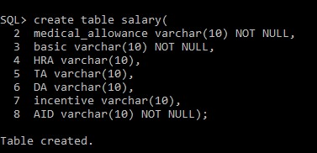

**Inserting Values in the table**

**Insertion in department**

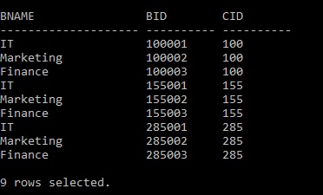

**Insertion in Salary** 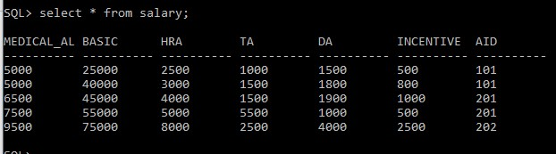

**Insertion in Employee**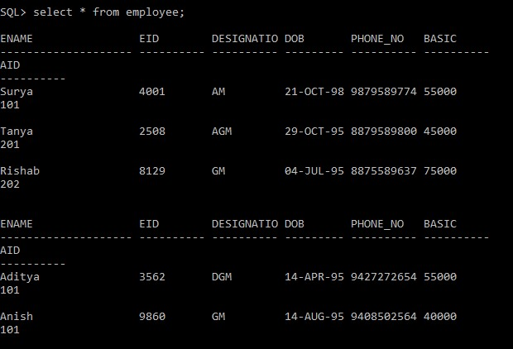

**Insertion in Attendance**

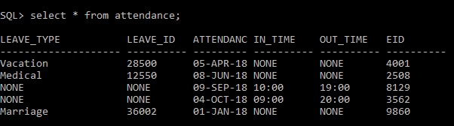

**Inner Join**

**Merging Employee and Attendance** 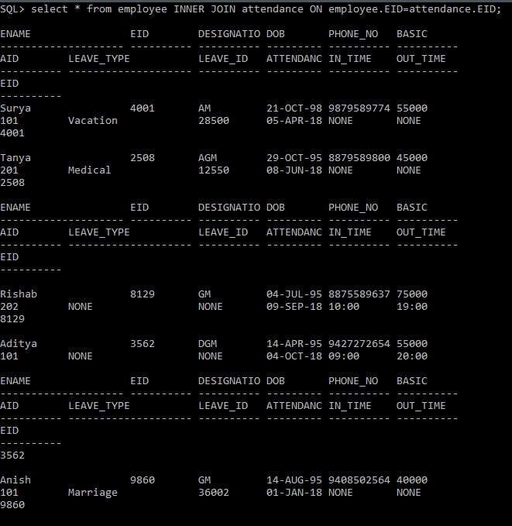

**Normalisation**

**First Normal Form (1NF)**

* A relation will be 1NF if it contains an atomic value.
* It states that an attribute of a table cannot hold multiple values. It must hold only single-valued attribute.
* First normal form disallows the multi-valued attribute, composite attribute, and their combinations.

**Second Normal Form (2NF)**

* In the 2NF, relational must be in 1NF.
* In the second normal form, all non-key attributes are fully functional dependent on the primary key.

**Third Normal Form (3NF)**

* A relation will be in 3NF if it is in 2NF and not contain any transitive partial dependency.
* 3NF is used to reduce the data duplication. It is also used to achieve the data integrity.
* If there is no transitive dependency for non-prime attributes, then the relation must be in third normal form.

A relation is in third normal form if it holds at least one of the following conditions for every non-trivial function dependency X → Y.

* X is a super key.
* Y is a prime attribute, i.e., each element of Y is part of some candidate key.

**Boyce-Codd Normal Form (BCNF)**

* A table is in BCNF if every functional dependency X → Y, X is the super key of the table.
* For BCNF, the table should be in 3NF, and for every FD, LHS is super key.

**USER:**

|  |  |  |  |  |
| --- | --- | --- | --- | --- |
| user_id | user_name | password | Email_id | user_type |

R=(user_id,user_name,password,email_id,user_type)

Functional dependencies:

user_id,passworduser_name,email_id,user_type

email_id,user_type user_id,user_name,password

Candidate keys are {passsword,user_id,email_id,user_type}

Relation R is in 1NF since there are only atomic values.

Relation R is in 2NF since there are no partial dependencies.

Relation R is in 3NF since there is no transitive dependency for non-prime attributes.

Relation R is in BCNF since for every functional dependency X → Y, X is the super key

**Department**

|  |  |
| --- | --- |
| dept_id | dept_name |

R=(dept_id,dept_name)

Functional dependencies:

dept_id dept_name

Candidate key is {dept_id}.

Relation R is in 1NF since there are only atomic values.

Relation R is in 2NF since there are no partial dependencies.

Relation R is in 3NF since there is no transitive dependency for non-prime attributes.

Relation R is in BCNF since for every functional dependency X → Y, X is the super key

**Employee**

|  |  |  |  |  |  |  |
| --- | --- | --- | --- | --- | --- | --- |
| emp_id | emp_mobile | emp_name | Emp_dob | Emp_doj | Emp_city | Emp_state |

R= (emp_id,emp_mobile_no,emp_name,emp_dob,emp_doj,

emp_city,emp_state)

Functional dependencies:

emp_id  emp_mobile_no,emp_name,emp_dob,emp_doj,

emp_city,emp_state

emp_cityemp_state

Candidate key is {emp_id}

Relation R is in 1NF since there are only atomic values.

Relation R is in 2NF since there are no partial dependencies.

To convert into 3NF, we would have to get rid of transitive dependencies. In relation R, the transitive dependency is

emp_cityemp_state,to get rid of it we decompose R

R1= (emp_id,emp_mobile_no,emp_name,emp_dob,emp_doj,emp_city)

|  |  |  |  |  |  |
| --- | --- | --- | --- | --- | --- |
| emp_id | emp_mobile_no | emp_name | emp_dob | emp_doj | emp_city |

R2=(emp_city,emp_state)

|  |  |
| --- | --- |
| emp_city | emp_state |

Relation R is in BCNF since for every functional dependency X → Y, X is the super key.

**Payroll:**

|  |  |  |  |  |  |  |
| --- | --- | --- | --- | --- | --- | --- |
| emp_id | emp_net_salary | reinbursement_date | Emp_gross | Emp_salary_year | Emp_salary_month | Transaction_id |

R=(emp_id,emp_net_salary,reinbursement_date,emp_gross,

emp_salary_year,emp_salary_month, transaction_id)

Functional dependencies:

emp_idemp_net_salary,emp_gross,emp_salary_year,

emp_salary_month

transaction_idemp_id,reinbursement_date

Candidate key is {transaction_id}

Relation R is in 1NF since there are only atomic values.

Relation R is in 2NF since there are no partial dependencies.

To convert into 3NF, we would have to get rid of transitive dependencies. In relation R, the transitive dependency is

transaction_idemp_id,reinbursement_date , to get rid of it we decompose R.

R1= (emp_id,emp_net_salary, emp_gross,emp_salary_year,emp_salary_month)

|  |  |  |  |  |
| --- | --- | --- | --- | --- |
| emp_id | emp_net_salary | emp_gross | emp_salary_  year | emp_salary_month |

R2= (transaction_id,emp_id,reinbursement_date)

|  |  |  |
| --- | --- | --- |
| transaction_id | emp_id | reinbursement_date |

Relation R is in BCNF since for every functional dependency X → Y, X is the super key.

**Paygrade:**

|  |  |  |  |  |  |  |
| --- | --- | --- | --- | --- | --- | --- |
| grade_name | grade_basic | grade_da | grade_ta | grade_bonus | grade_pf | grade_id |

R=(grade_name, grade_basic,grade_da,grade_ta,grade_bonus,grade_pf,grade_id)

Functional dependencies:

grade_id grade_name,grade_basic,grade_da,grade_ta,grade_bonus, grade_pf

Candidate key is {grade_id}

Relation R is in 1NF since there are only atomic values.

Relation R is in 2NF since there are no partial dependencies.

Relation R is in 3NF since there is no transitive dependency for non-prime attributes.

Relation R is in BCNF since for every functional dependency X → Y, X is the super key

**Relation User**

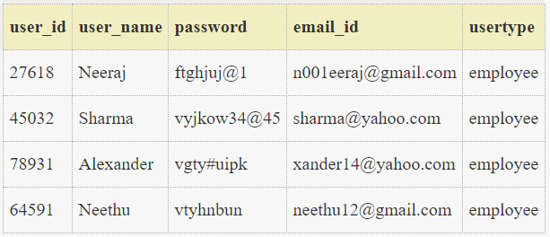

User is already in 1NF

**Relation Department**

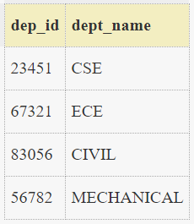

Department is already in 1NF

**Relation Employee**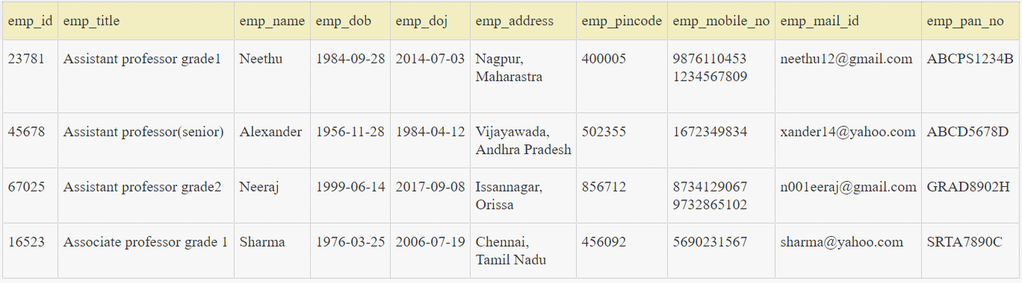

Employee in 1NF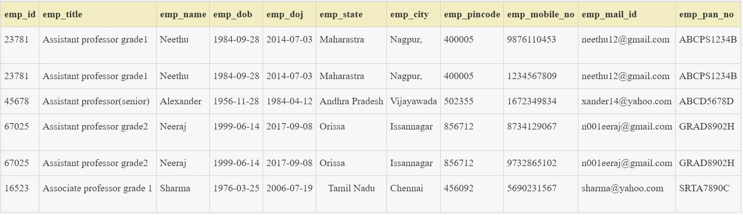

**Relation User**User is decomposed into 2 tables 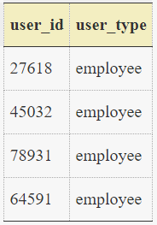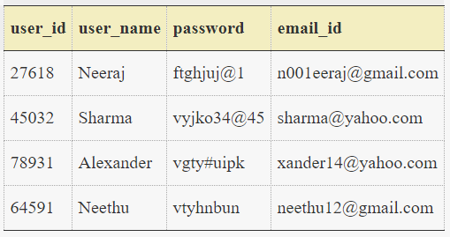

**Relation Department**



Department is already in 2NF

**Relation Employee**Already employee is in 2NF

**Relation user type**



Already user type is in 3 NF​

**Relation user info**



Already user info is in 3NF

**Relation Department**



Already department is in 3 NF

**Relation Employee**



Employee is decomposed into 2 tables

**Employee info**

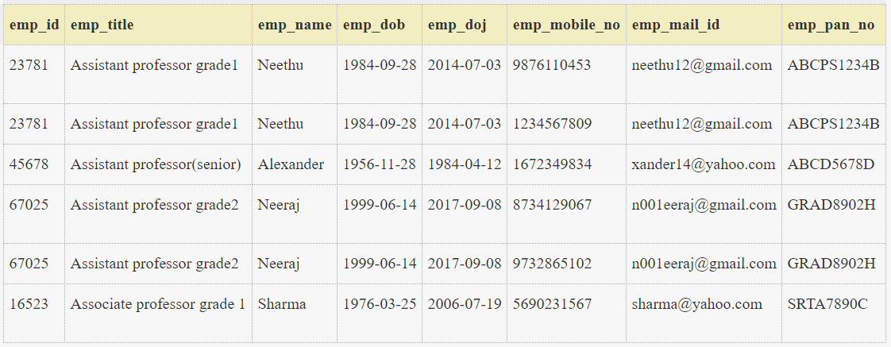

**Employee state**

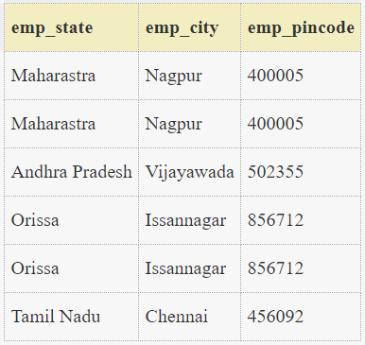

**SAMPLE CODE FOR DATABASE AND CONNECTIVITY:**

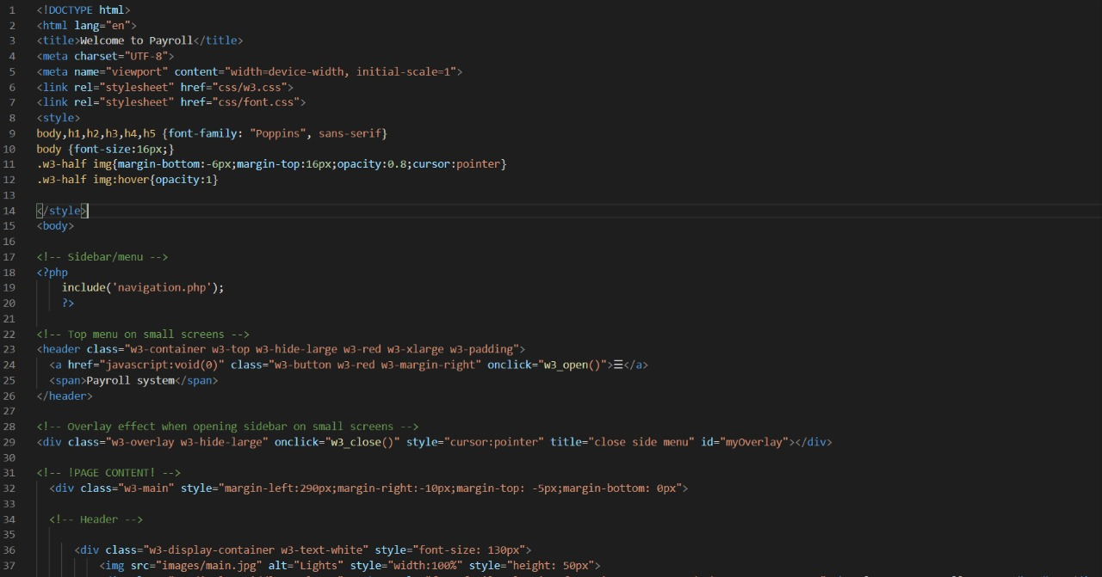

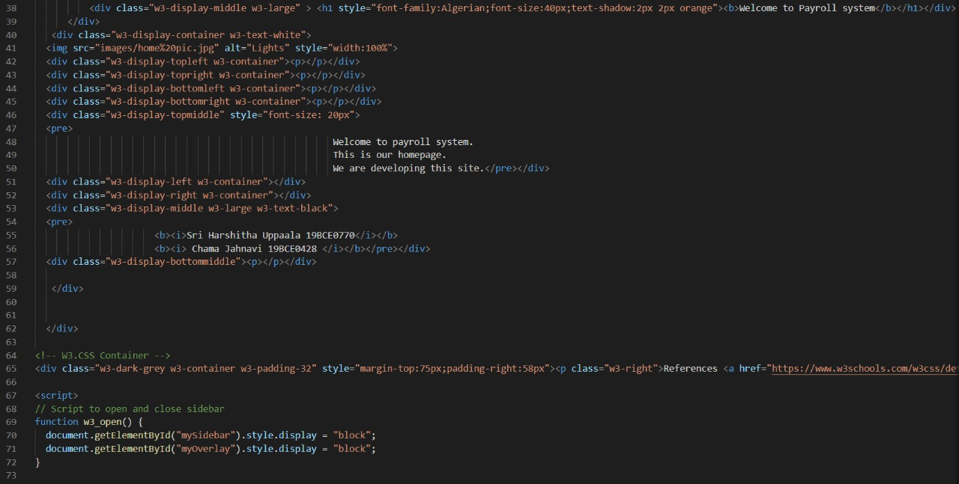

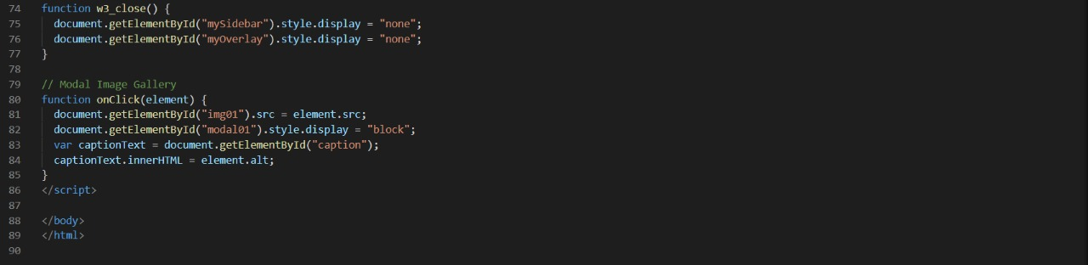

**SCREENSHOTS OF MANIPULATION AT FRONT END:**

## MODULE WISE EXPLANATION

***Role of the admin:***

* Admin can add new department, add new employee and manage employee details.
* Admin is a responsible for operating the whole system. Admin can log in using a username and password. Admin has rights to add a new Employee. Each employee has a unique employee ID. The admin can check leave, overtime and he add and remove an employee. According to this, amount can be deducted from or added to salary.

**Admin login page:**

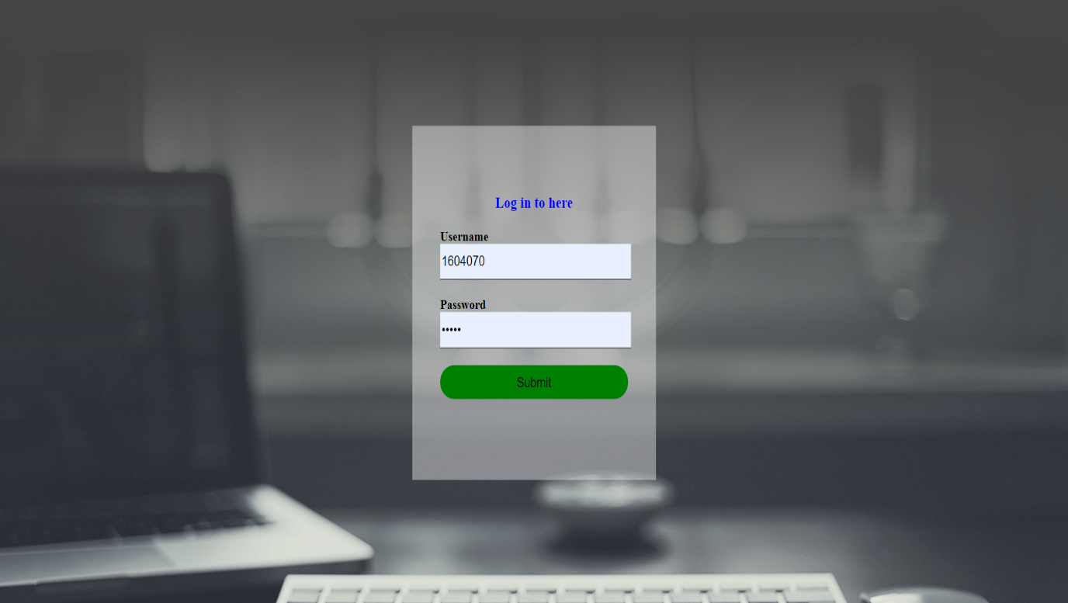

**Home page :**

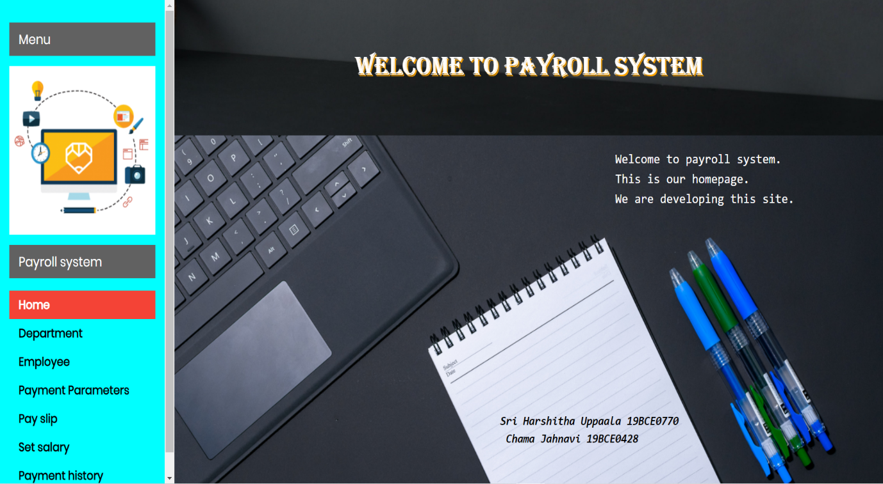

**Module 1: Employee Management**

* Even after all the digitization of the industry, there will always be a requirement of an eligible employee for the correct management of events. These are the individual who works part-time or full-time by the contract of employment with the administration of the company, which could be written or oral.

* The employee entity contains all the information about the employees working in the company.

* The employees will be hired by the administration and further, it has a relationship with the department entity because all the employee will be working in particular department.

1. **Employee_id:**

This will be the primary key for this entity. It will be unique for every employee hired by the administration. It will help in identifying the particular employee easily. This gets useful when two employee has a similar name like conditions.

1. **Employee_name:**

This is required for the verification purpose. Usually on government issued id cards it has a name as identification. Also, it is easy to remember a name than the id.

1. **Employee_phone:**

It is good to have employee’s contact number to have immediate communication regarding the work.

1. **Employee_email:**

It is required when a bank needs to make an announcement. So, they will select the employee’s email and simply broadcast the announcement. It can also be helpful in verifying the employee’s identity online.

1. **Employee_address:**

In any case, the employee address needed for example sending any email or documents at the employee’s residence. It is also required for verification if the employee’s given personal information is right or wrong.

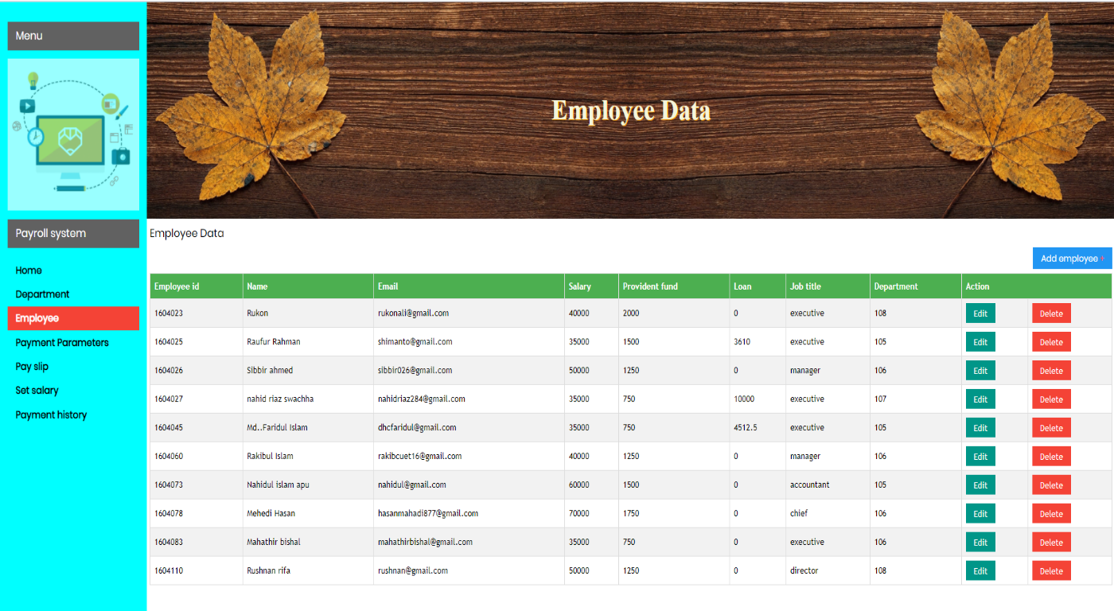

**Adding an Employee** 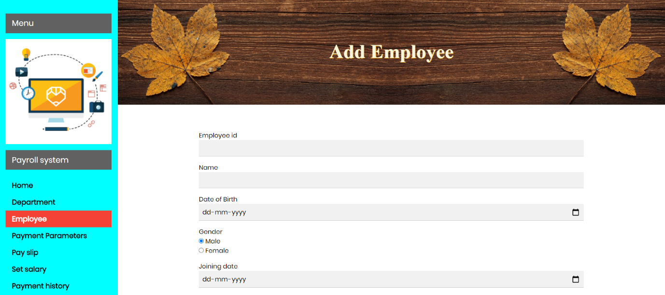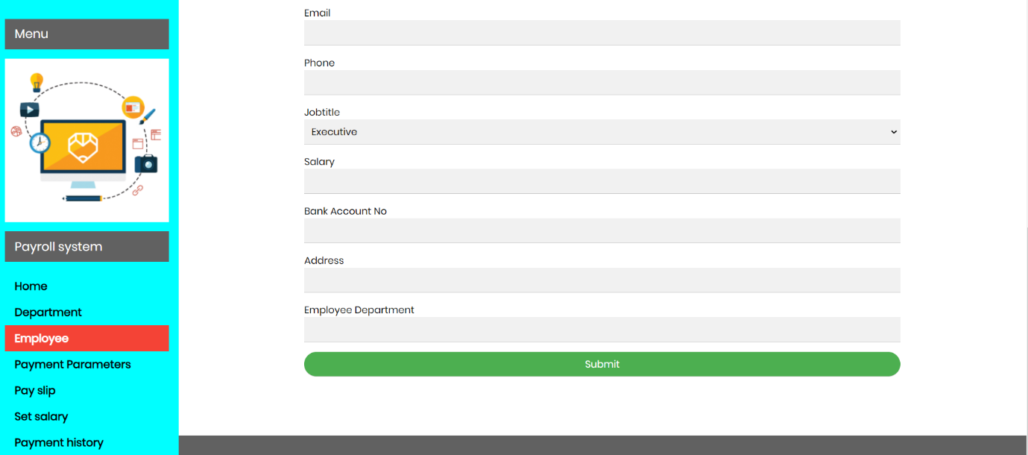

**Module 2: Department Management**

* These are the different fragments of the company which are divided as the department. Each of the department has assigned the id and name to avoid any kind of confusion.
* There are 10 departments and they include IT, marketing, finance, electronics, electrical, communication, management, logistics, r&d and accounts.
* This entity will help in keeping the track of the job profile of the employee. The departments are the inner fragments of the company. Each Employee profile will be assigned to one department in which will have the details about their job. The department entity will have following attributes:

1. **Department_id:**

This is the primary key for the table it will help identify each job profile uniquely in with the department. This will be unique for every designation of departments.

1. **Department_name:**

It will contain the name of the department to avoid confusion to clear and avoid the confusion from the id. Usually, the department names are unique themselves but creating it is a good option that because it uses less storage space than a name.

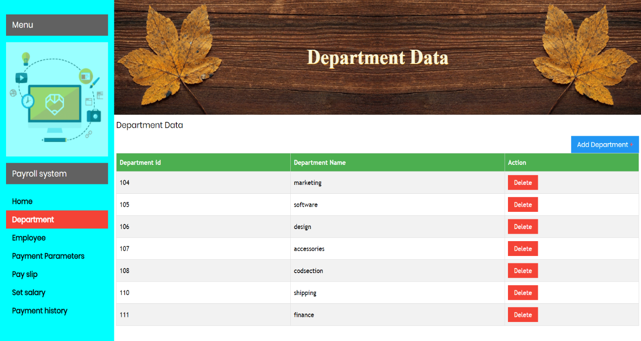

**Adding New Department** 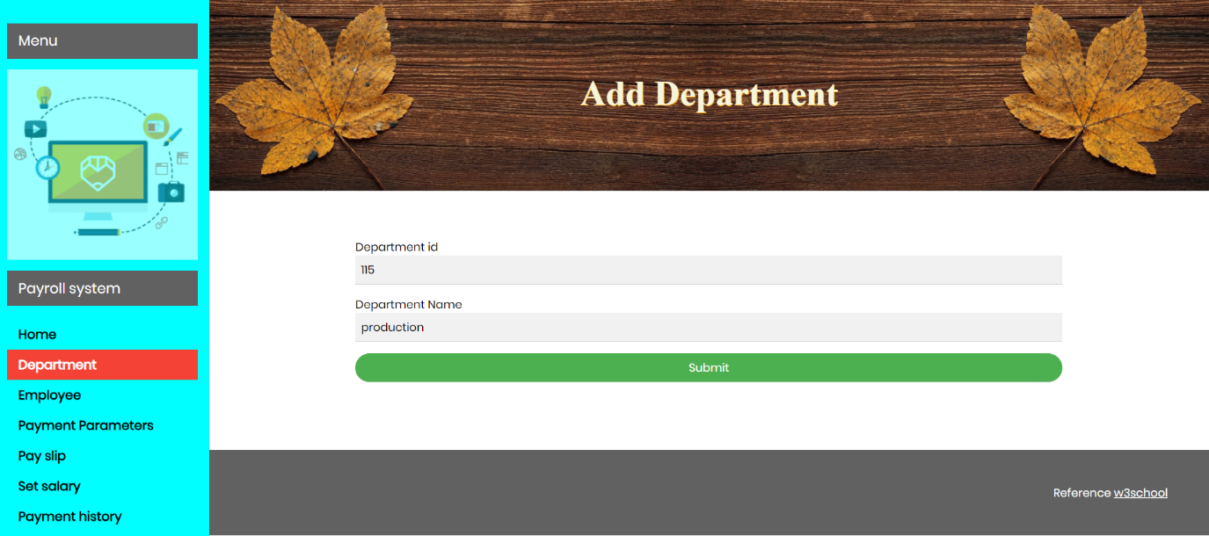

**Module 3: Salary Calculator Module**

* It is a periodic payment from an administration to an employee
* It could be different for the employees working in different department or designation
* For the business company, it could be the cost of acquiring and retaining human resources for running the company’s business operations. In accounting, salaries are recorded in payroll accounts these are just the accounts which are designated by the company where salary will be credited after the decided period.
* Admin can generate month wise salary for each employee one by one
* This is the important entity because the purpose of this system is to calculate the salary. This will have all the information of the employee to calculate the employee salary and generate the payment slip.

1. **Employee_id:**

It will take the employee id as value. So later it can be used to identify whose salary it has stored.

1. **Deduction:**

Every employee will have some deduction in salary based on the different factors for ex:

attendence can be one of them. It will check the deductions based on the values of particular id before calculation.

1. **Bonus:**

If there is any bonus by the administration then there will be the amount which will be added to the salary.

1. **Absence:**

It will have the value that in the total working day how many days the employee has not come to work and on the based on a daily basis the salary can be calculated.

1. **Loan:**

If the employee has taken any loan from the company if yes then the instalment will be also be deducted from the salary of the employee.

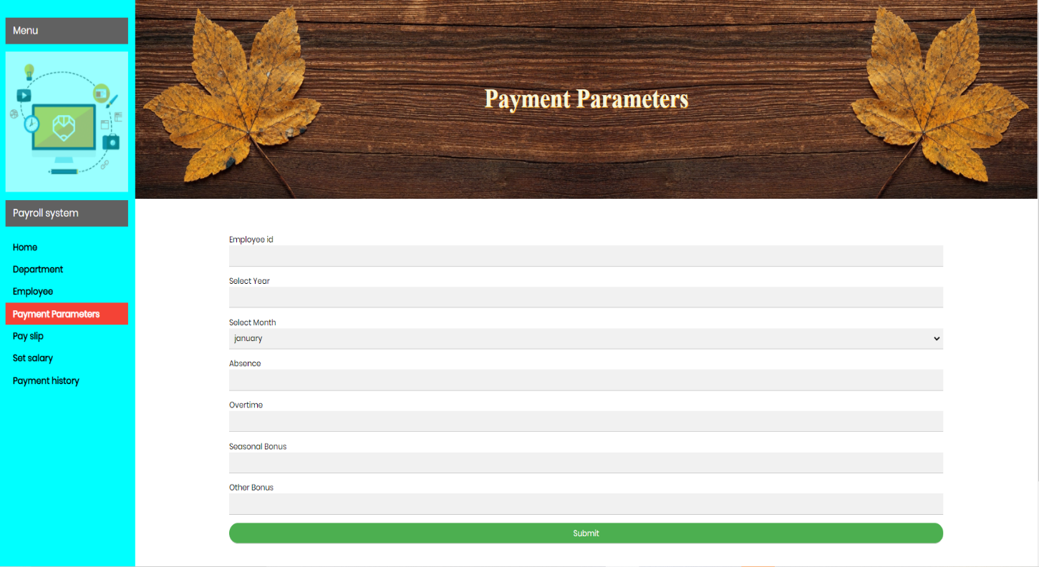

## Module 4: Payment Receipt (Pay Slip) Module

* Payment parameters include leave, overtime, seasonal bonus and other bonuses. At the time of set salary, we can manually set a salary amount for a given designation such as executive, director, manager etc. Admin can generate and view Employee details, salary of employees for a particular month and generate slip for the same.
* The slip shows the payment number, month, year, bank account number of the employee and the total salary.

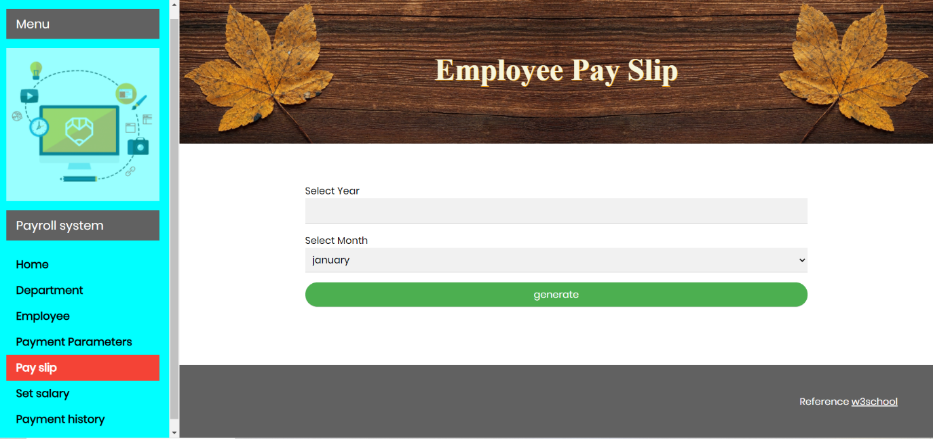

**Pay Slip Show**

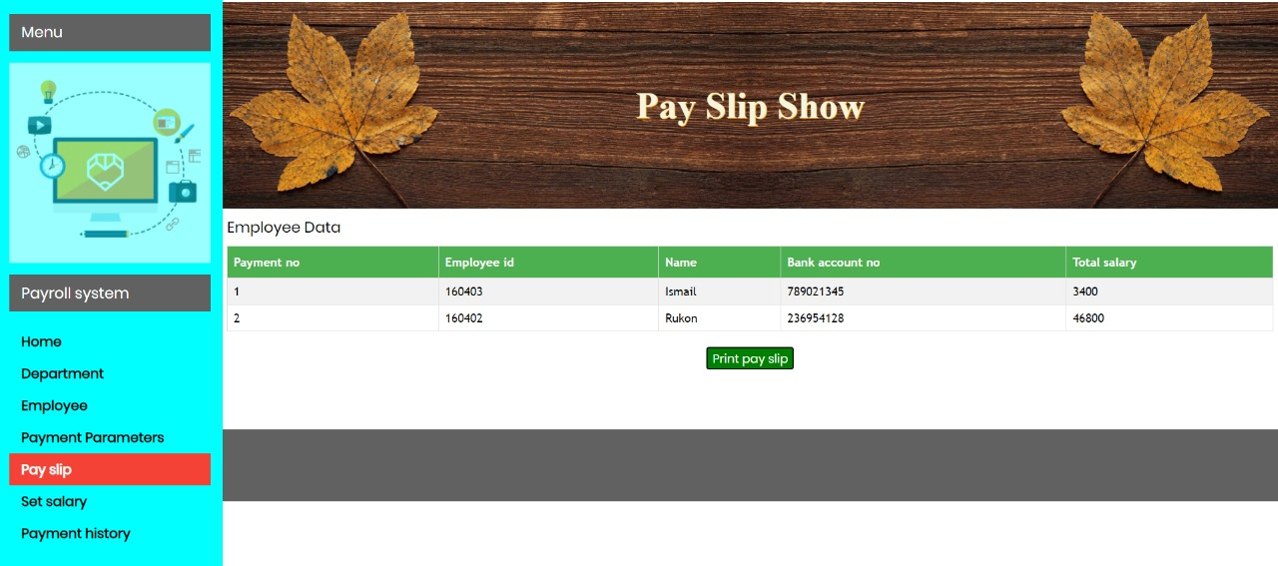

Pay Slip

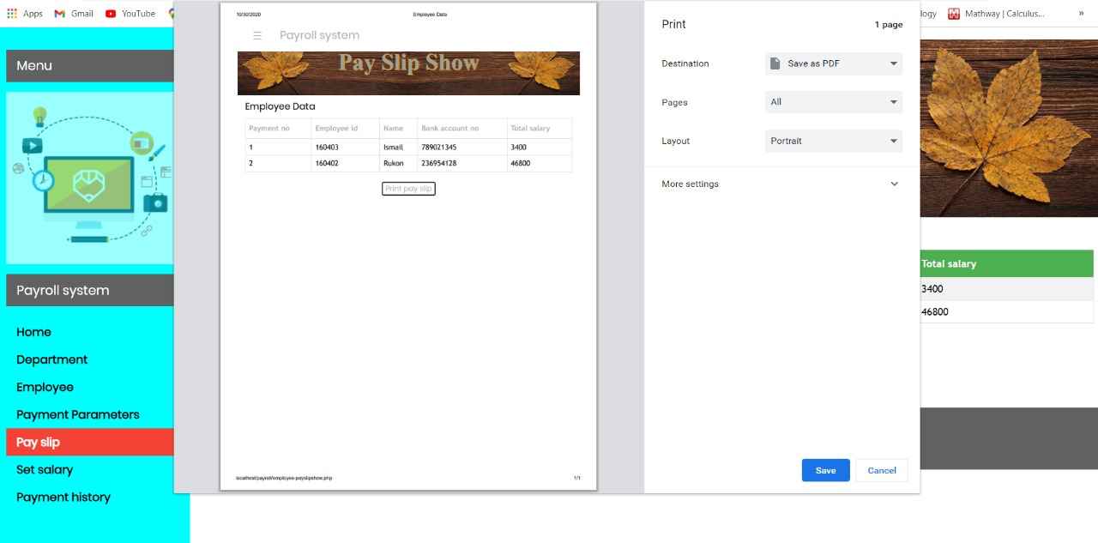

**Employee Set Salary**

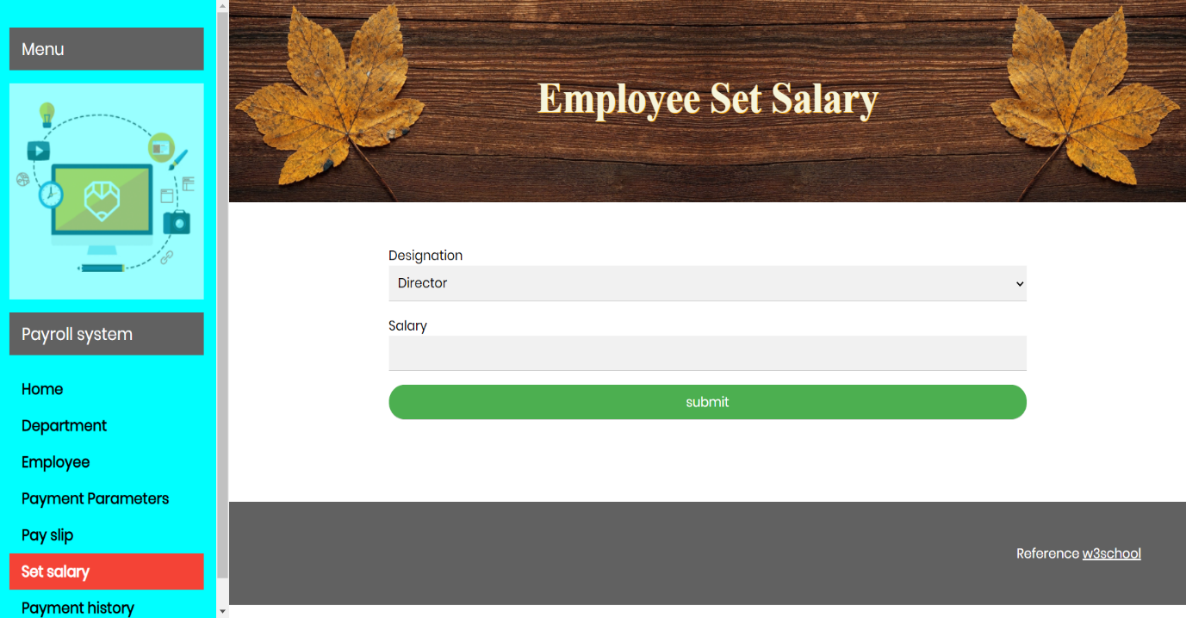

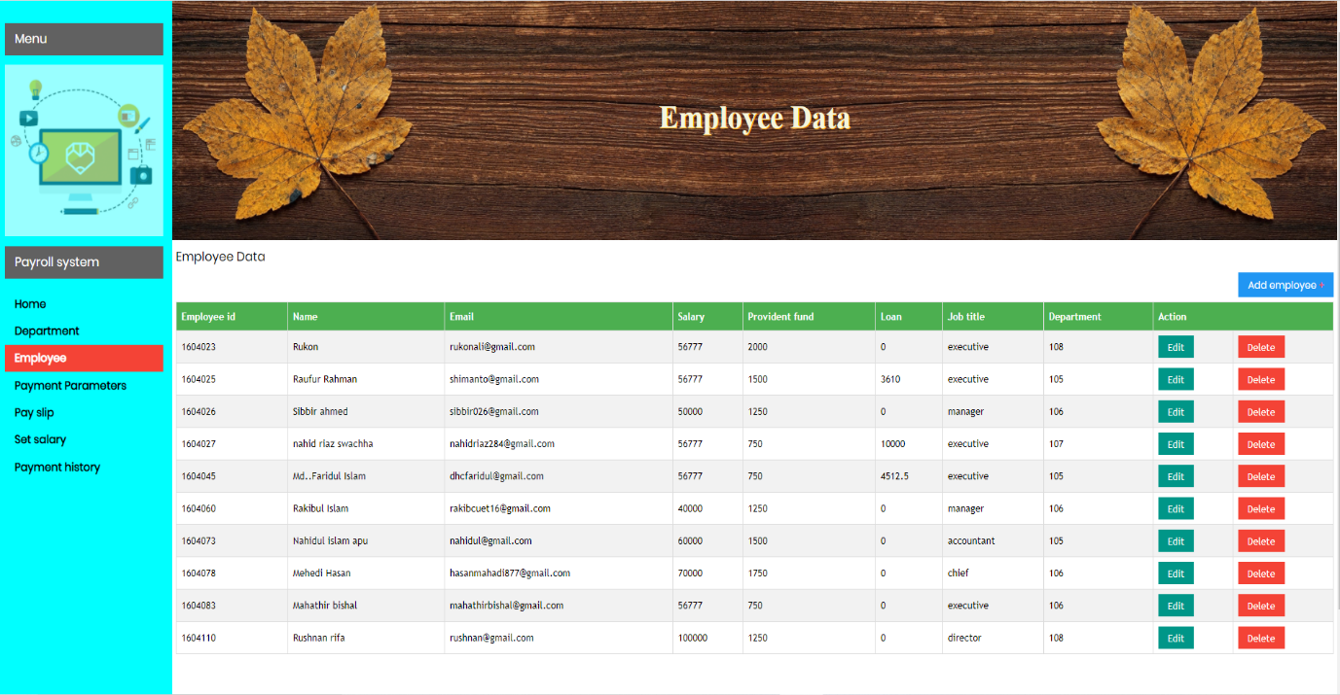

**Payment History**

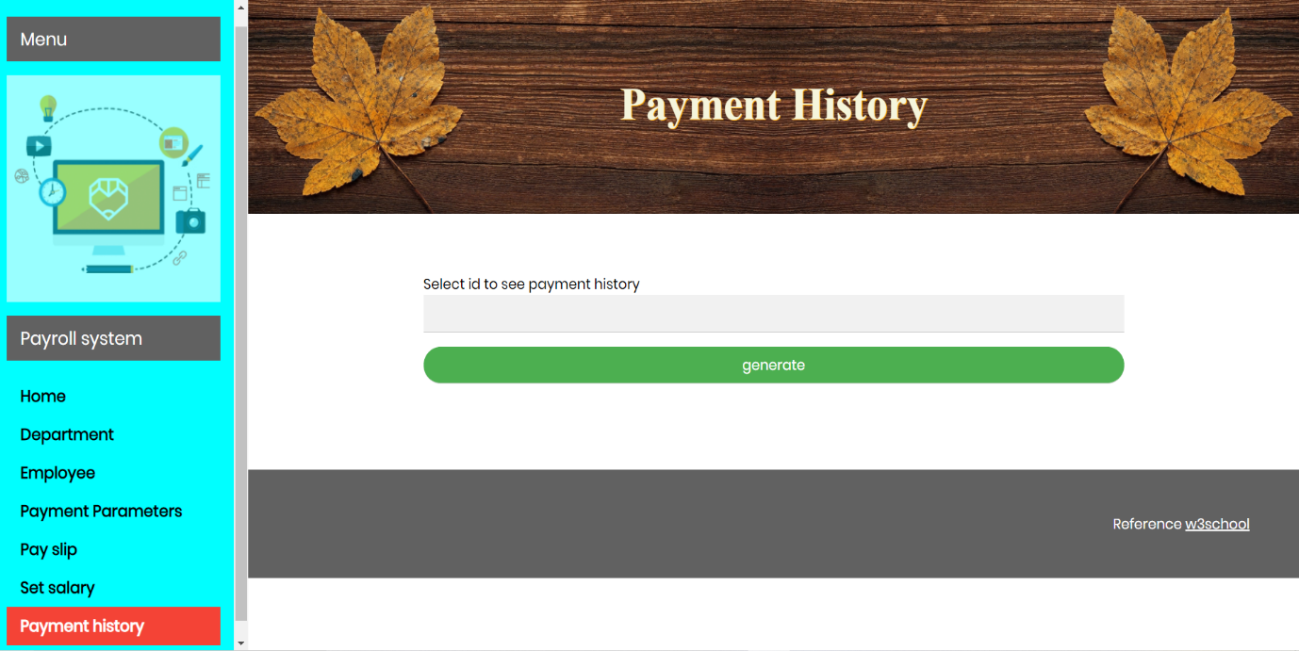

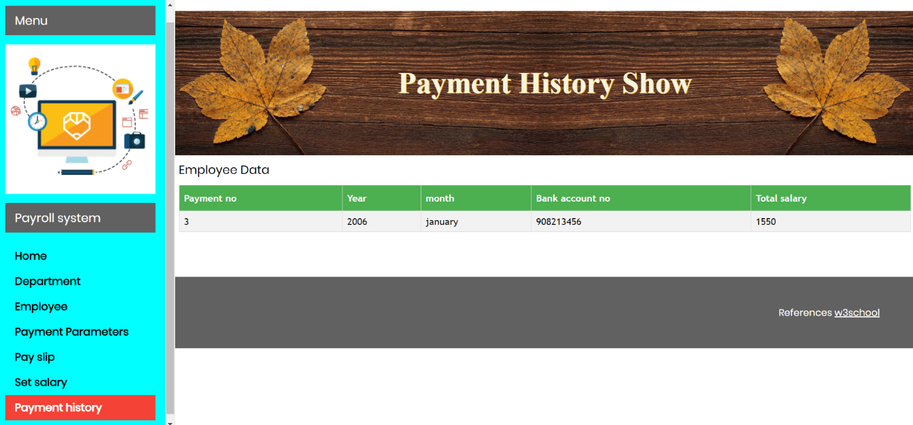

**SCREENSHOTS OF MANIPULATION AT BACK END:**

**Database Tables:**

**User Table Database Structure:**

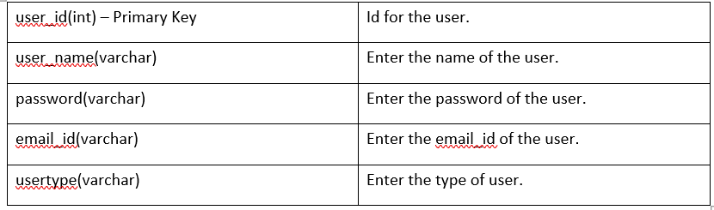

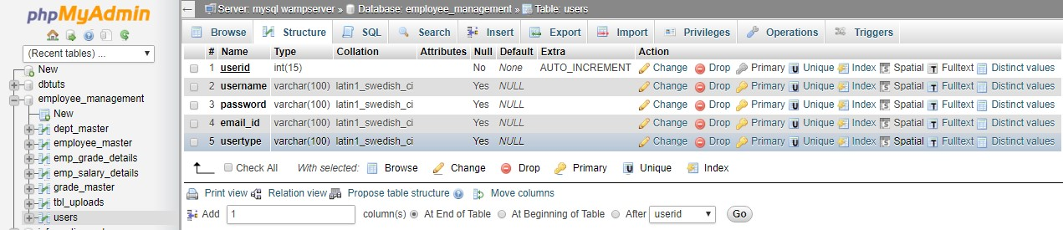

**Department Table Database Structure:**

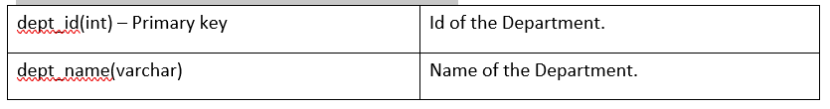

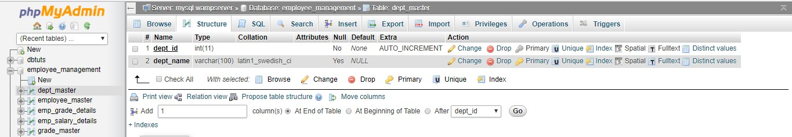

**Grade Table Database Structure:**

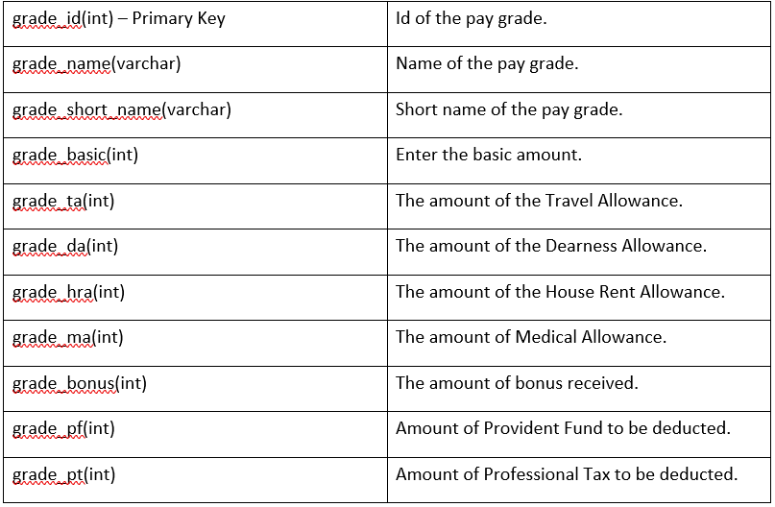

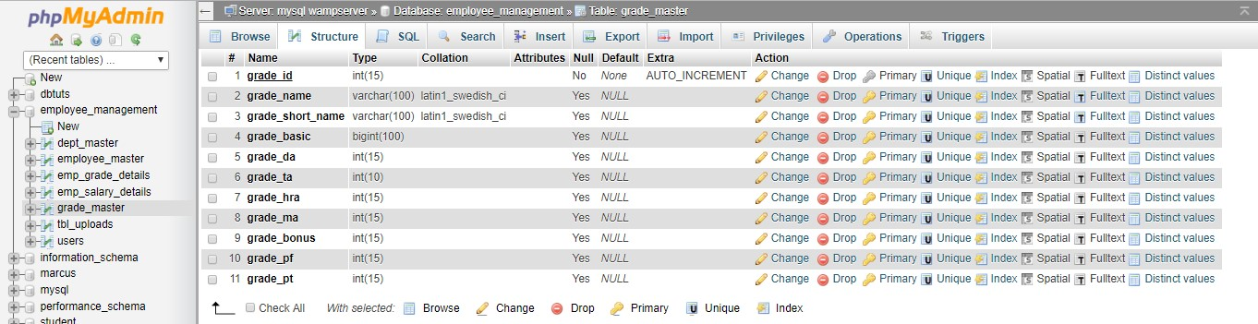

**Employee Table Database Structure:**

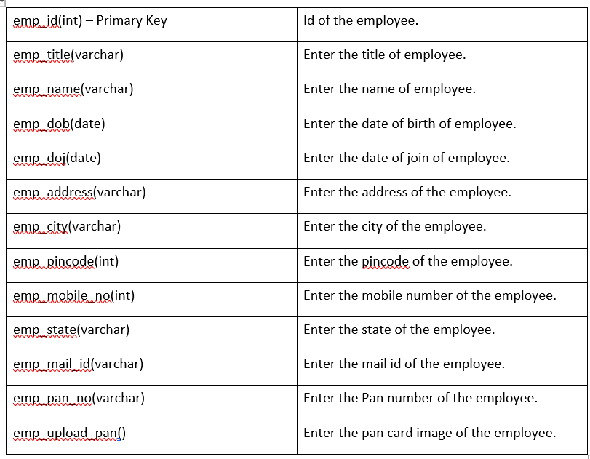

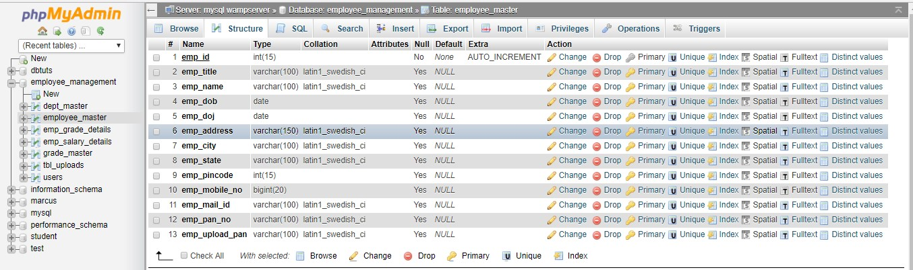

**Employee Grade Details Table Database Structure:**

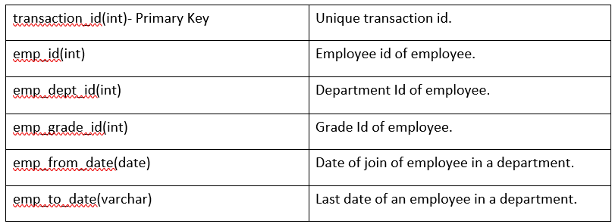

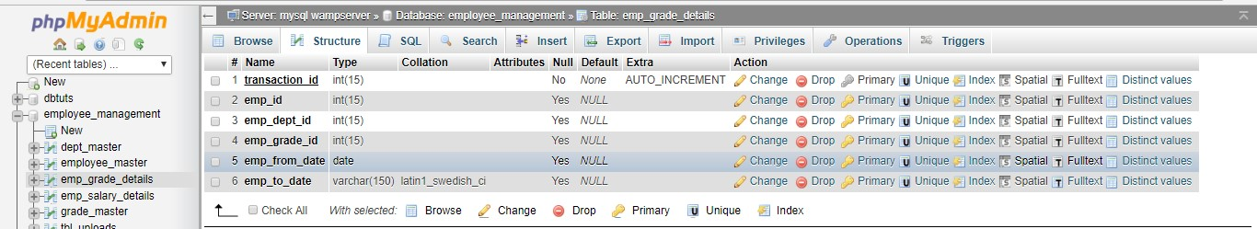

**Employee Salary Details Table Database Structure:**

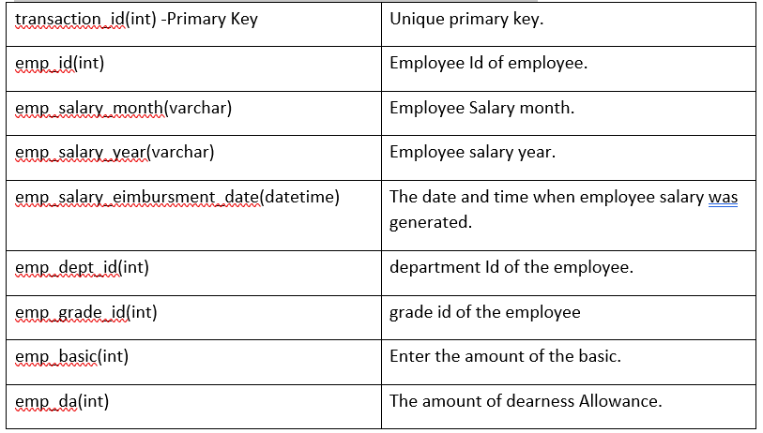

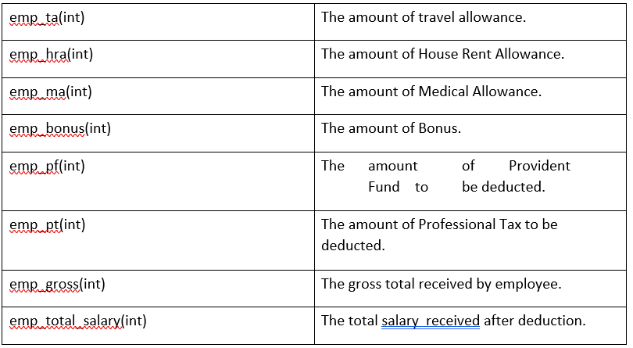

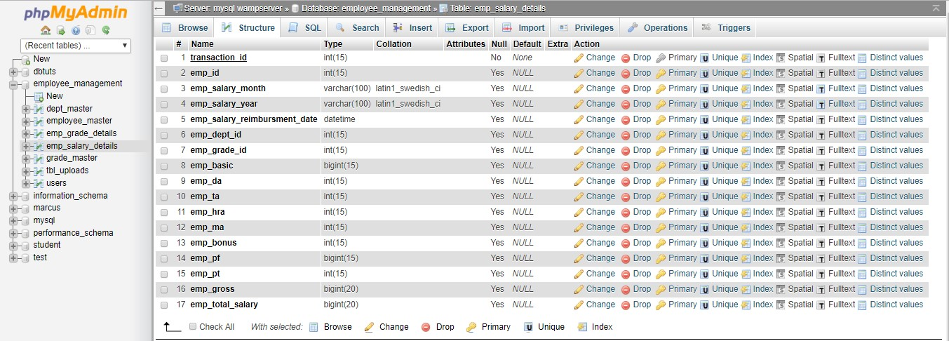

**REFERENCES:**

* [**https://www.greythr.com/complete-guide-payroll/**](https://www.greythr.com/complete-guide-payroll/)
* [**https://www.zoho.com/in/payroll/online-payroll-management/**](https://www.zoho.com/in/payroll/online-payroll-management/)
* [**http://www.dolphintechnologies.in/payroll-software.html**](http://www.dolphintechnologies.in/payroll-software.html)